Tuesday 9th September 2025

Dear Parents/Carers,

Young Voices 2025 Trip – Years 3 and 4


We are very excited that Year 3 and Year 4 are taking part in a Young Voices concert at the BP Pulse Arena, Resorts World where the children perform in of the biggest choirs in the world! This year is also very special because it is the 30th anniversary of Young Voices! This will be a very special event and is recommended as an amazing opportunity for all pupils to participate in. Each year the children and parents always have an amazing time!

The concert is on Wednesday 7th January 2026. We will be taking the children by coach, leaving school at approximately 12.30pm to be at the venue by 1.30pm in order to rehearse with all of the other schools. The concert then starts at 7pm.

We will have lunch as normal at school before we leave. The children will need to bring food with them to eat at teatime (we will send more details nearer the time along with the names of the staff that will be attending).

The concert ends at approximately 9.15pm so you will need to collect your child from school at approximately 10pm. (Children CANNOT be collected from the arena).

The cost of this trip will be £10 which will cover the cost of the coach and participation in the concert.

Please log onto Parent Pay to make payment for this trip by Friday 26th September 2025. Please note that we will not be able to add more children to our numbers after this date. Consent forms will follow closer to the event.


Music Room
Please use this QR code sign up to the Music Room to be able to purchase parent tickets and to allow the children to practise the lyrics, sign language and dance moves.

PLEASE TURN OVER FOR TICKET INFORMATION

PARENT TICKETS FOR Young Voices 2026

Parents are welcome to come along to watch the concert which will start at 7pm and end at 9.15pm. You will need to make your own arrangements for travelling to and from the arena.

You will then need to collect your child from school at approximately 10pm. (Children CANNOT be collected from the arena).

If you would like tickets to come and watch the concert, they cost £24 per person and need to be brought from Young Voices themselves and not through school. You can buy as many tickets as you like. All tickets are allocated closer to the date of the performance.

How to purchase tickets
- Sign up to the music room using the QR code on the front of this letter
- Click on shop and then products
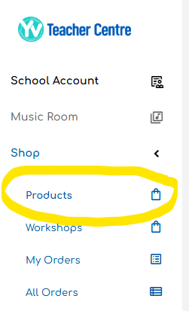

- Purchase your tickets through the shop.

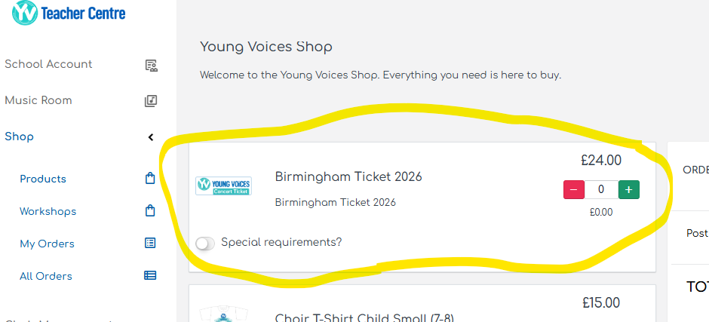

Please note that there is a deadline for parents to buy tickets which is Friday 31st October 2025. Once this deadline has passed, you will need to wait for any leftover tickets to go on general sale to the public and purchase them directly from the venue (subject to availability).

If you have any questions, please do not hesitate to contact me.

Kind Regards

Mr P Smith
Music Lead
Tuesday 9th September 2025

Dear Parents/Carers,

Year 5 and 6 Young Voices Choir

Young Voices is returning this year for a special 30th anniversary celebration! We are offering the opportunity for any Year 5 and 6 children who wish to go to Young Voices with the year 3 and 4 classes this year.

The concert is on Wednesday 7th January 2026 at the BP Pulse Arena, Resorts World. We will be taking the children by coach, leaving school at approximately 12.30pm to be at the venue by 1.30pm in order to rehearse with all of the other schools. The concert then starts at 7pm.

We will have lunch as normal at school before we leave. The children will need to bring food with them to eat at teatime (we will send more details nearer the time along with the names of the staff that will be attending).

To be able to qualify for this visit, pupils MUST attend the choir on Wednesdays after school which will begin after October half term (Wednesday 5th November – Wednesday 10th December) in order to learn the songs they will be singing. There will be no opportunity for the songs to be learned in class for years 5 and 6.

The cost for the choir will be the usual after school cost of £4 per week due to sessions taking place after school hours. This is a total of £24 for 6 weeks and includes the cost of the coach for the trip.
Please log onto Parent Pay to make payment by Friday 26th September 2025. Please note that we will not be able to add more children to our numbers after this date. Consent forms will follow closer to the event.

Places for the choir are limited to 20 places and will be allocated on a first come, first served basis.
Music Room

Please use this QR code sign up to the Music Room to be able to purchase parent tickets and to allow the children to practise the lyrics, sign language and dance moves.

PLEASE TURN OVER FOR TICKET INFORMATION

PARENT TICKETS FOR Young Voices 2026

Parents are welcome to come along to watch the concert which will start at 7pm and end at 9.15pm. You will need to make your own arrangements for travelling to and from the arena.

You will then need to collect your child from school at approximately 10pm. (Children CANNOT be collected from the arena).

If you would like tickets to come and watch the concert, they cost £24 per person and need to be brought from Young Voices themselves and not through school. You can buy as many tickets as you like. All tickets are allocated closer to the date of the performance.

How to purchase tickets
- Sign up to the music room using the QR code on the front of this letter
- Click on shop and then products

- Purchase your tickets through the shop.

Please note that there is a deadline for parents to buy tickets which is Friday 31st October 2025. Once this deadline has passed, you will need to wait for any leftover tickets to go on general sale to the public and purchase them directly from the venue (subject to availability).

If you have any questions, please do not hesitate to contact me.

Kind Regards

Mr P Smith
Music Lead

